**Manuals for ‘Manage Testimonial’**

**Brief of the ‘Manage Testimonial’ –** This is the page where we manage the testimonial for the site.

**1. How to manage testimonial -.**

Steps:

1. Login to the site and go to ‘Masters’ tab and click on ‘Manage Testimonial’.
2. On ‘Manage Testimonial’ page the listing of testimonial and ‘Add New Testimonial’ button will display.
3. On this page we can edit and delete the existing records.
4. Click on ‘Add New Testimonial’ button for add new records.
5. The added new testimonial will display on all pages.

1.

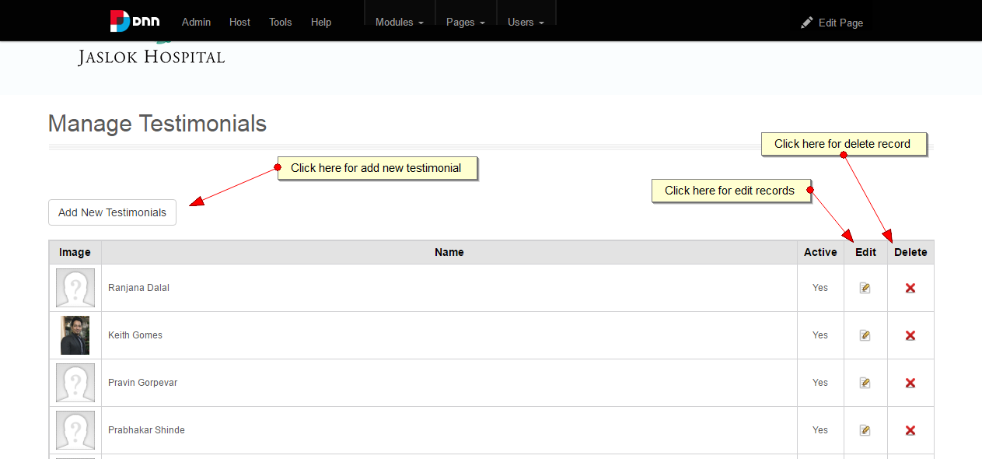

2.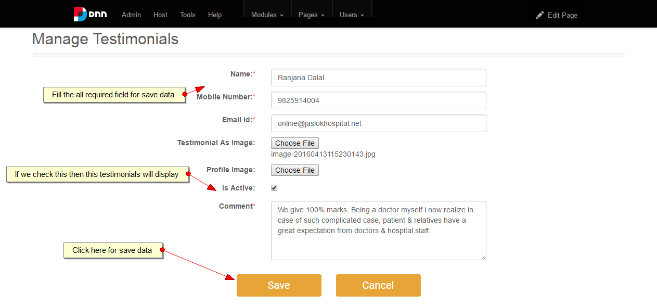

3.

